Program Information | [Lesson Title]  Exploring the Scientific Method Through Experiment, Vocabulary, and Design |  |  |  |  | TEACHER NAME  Mary Grace DeStefanis |  |  | PROGRAM NAME  Parma City School District
Program Information | [Unit Title] |  |  |  |  | NRS EFL(s)  3 – 4 |  |  | TIME FRAME  120 minutes
Instruction | ABE/ASE Standards – English Language Arts and Literacy
Instruction | Reading (R) |  | Writing (W) |  | Speaking & Listening (S) |  |  | Language (L)
Instruction | Foundational Skills | R.3.2 | Text Types and Purposes |  | Comprehension and Collaboration |  | S.3.1  S.4.1 | Conventions of Standard English
Instruction | Key Ideas and Details | R.3.3  R.4.1  R.3.7 | Production and Distribution of Writing |  | Presentation of Knowledge and Ideas |  |  | Knowledge of Language
Instruction | Craft and Structure | R.3.10 | Research to Build and Present Knowledge |  |  |  |  | Vocabulary Acquisition and Use
Instruction | Integration of Knowledge and Ideas | R.3.14  R.3.15  R.4.10  R.4.11 |  |  |  |  |  | Benchmarks identified in RED are priority benchmarks. To view a complete list of priority benchmarks and related Ohio Aspire lesson plans, please see the Curriculum Alignments located on the Teacher Resource Center (TRC).
Instruction | LEARNER OUTCOME(S)  - Students will be able to match up vocabulary and definitions related to scientific experimentation with 100% accuracy. |  |  |  |  | ASSESSMENT TOOLS/METHODS  Formative:  - “I Know” Statement Sheet  - Teacher Observation

- Brief classroom explanations
- Students will be able to identify the various components
of the scientific process and experiment with 100% Summative:
accuracy. • Complete controlled Experiment Organizer with a
score of 2 or 3
- Students will be able to enumerate three ways by which a • Exit Ticket: Crossword Puzzle scientific experiment may be improved.

- Students will be able to design a well-constructed experiment.
LEARNER PRIOR KNOWLEDGE

- Scientific Method Steps
INSTRUCTIONAL ACTIVITIES RESOURCES

- Teacher will put the following words on the board: White/chalk board Control, Constant, Independent Variable, Dependent Variable, Data
Collection/Measurement, Conclusion, Projector, ability to project
Hypothesis.
Computer
- Teacher will ask students the meaning of these words from what
they remember or think and write down answers for later evaluation. Internet access
- Teacher will then put “I Know” Statements – The Scientific Method on
the doc camera and have students write down the questions they can Highlighters
answer affirmatively.
Independent and Dependent Variable Examples
(attached)
- Teacher will tell students that by the end of this lesson, they will be

 | able to answer all the questions in the affirmative.  - Teacher then will circle the words written on the board: independent/dependent variables.  - Teacher will place Independent and Dependent Variable Examples  (attached) on the overhead or doc camera.  - Teacher will ask for a volunteer to read the definitions on the first section of the page.  - The teacher will highlight the vocabulary words, independent and dependent variable, in addition to the words “Input”, “output”. Teacher will explain that these words will be important in the next lesson when we graph results of experiments.  - Teacher asks another student to read the section “Using  Inde pen dent an d De pen de nt V aria bles” and the first example.  - Teacher asks student to “p araphrase” the definition on a sheet of paper and refers students to use certain context clues and key words to assist them in formulating their own definitions.  - Teacher asks for a couple of volunteers to read their paraphrased definitions.  - Teacher will pass out the Independent and Dependent Variables Chart (attached) and ask students in pairs to fill out the chart for the three examples on the bottom of the page.  - Teacher will ask students to raise their hands when they have identified the independent and dependent variables and written them on the chart. Teacher will check answers and help where needed.  - When students are finished, teacher will lead brief discussion on the value of this graphic organizer in assisting their comprehension of independent and dependent variables.  - Teacher puts Hypothesis, Variables and Controls (attached) on the | Student copies of Independent and Dependent Variables Chart (attached)  Hypothesis, Variables and Controls (attached)  Student copies of Experiment Design Vocabulary Explain (attached)  Student copies of Scientific Method – Manipulated and Responding Variables (attached)  Student copies of Controlled Experiment Organizer  (attached)  Student copies of The Scientific Method crossword puzzle (attached)

doc camera and asks students to offer suggestions for the definition of “control” based on the examples included.
- Teacher leads students through completion of example 1.
- Teacher relies on student answers for completion of examples 2 and 3.
- Working in pairs, students complete #4 and 5.
- Teacher goes around to help and to check answers.
- Using thumbs up, down, or shrugged shoulders, teacher polls students as to their confidence level in identifying components (vocabulary words) of a scientific experiment.

- Pass out Experiment Design Vocabulary Explain (attached)
  - Have students individually complete sheet. Give students 10 minutes.
  - When 10 minutes is up, have them compare their answers with one other person.
  - Discuss results.

- Pass out Scientific Method – Manipulated and Responding Variables
(attached).
  - Do first experiment as a class.
  - Have students complete the Controlled Experiment Organizer
(attached) as they work through the second experiment.
  - Review student answers for experiment 2 and ask students how they would improve the experiment.

- Exit Ticket
  - Have students complete and turn in The Scientific Method crossword puzzle (attached).

DIFFERENTIATION

Graphic Organizers, Read Aloud, Frequent observation, Pairs
Reflection | TEACHER REFLECTION/LESSON EVALUATION
Reflection | ADDITIONAL INFORMATION

Name De -------
Controlled Experiment Organizer

o·irecfions:
Use th·1s orQan.izer as a QUI"de to conduct a controIIed expen.ment.

Title:
Problem:
Hypothesis:
Procedure(s):
Dependent Variable:
Independent Variable:
Control:
Observation:
Data:
Conclusion:

8

Name --
Class --

Hypothesis, Variables and Controls

Directions: Write a hypothesis using if, then and because for each Problem Write the independent variable, control and dependent variable of each problem

Example
Problem: What will happen if I put my hand in a bucket of ice water for 4 minutes?
Hypothesis: IF I put my hand in a bucket of ice water for 4 minutes, THEN my hand will hurt, BECAUSE the cold will make my blood vessels constrict.
Independent Variable: Hand placed in old ice water Control: hand not in bucket of ice water
Dependent Variable: pain in hand. What will happen if a houseplant is not watered for three weeks?
Hypothesis: _

Independent Variable: _

Control: -------------------

Dependent Variable: _

- What will happen to a plant when we add fertilizer (nutrients to the soil)?
Hypothesis: _

Independent Variable: _

Control: -------------------

Dependent Variable: _

- Will eating a breath mint make a persons breath smell better?
Hypothesis:-----------------

Independent Variable: _

Control: ------------------

Dependent Variable: _

- Will Rogain grow hair on bald people? (Rogain is a hair growing product)
Hypothesis: _

Independent Variable: _

Control: ------------------

Dependent Variable: _

- Will hot water clean clothes better than cold water? Hypothesis: _

Independent Variable: _

Control: ------------------

Dependent Variable: _

What does running do to your heart rate?
Hypothesis: _

Independent Variable: _
Control: ------------------

Dependent Variable: _
“I Know ” Statements – The Scientific Method

Directions: Put a check mark next to each of the statements you know or know how to do.

  - I can name five of the possible six steps that define the scientific method.

  - I know the difference between an independent variable and a dependent variable.

  - I can pick out the constants in any experiment.

  - I understand the importance of constants in an experiment.

  - I know what a control group is in a designed scientific experiment and can it explain it well enough, using examples, to someone else so that he/she understands the term.

  - I know the definition of a hypothesis.

  - I know how to write a hypothesis in an IF/THEN format

  - I know at least three ways I can explain the difference between a dependent variable and an independent variable.

  - I can apply my understanding of the components of an experimental design to answer GED-type questions.

  - I can graphically display the scientific method after reading about an experiment.
examples.yourdictionary.com http://examples.yourdictionary.com/independent-and-dependent-variable-examples.html

Independent and Dependent Variable Examples

Generally speaking, in any given model or equation, there are two types of variables:

Independent variables - The values that can be changed in a given model or equation. They provide the "input" which is modified by the model to change the "output."
Dependent variables - The values that result from the independent variables.

Using Independent and Dependent Variables

The definition of an independent or dependent variable is more-or-less universal in both statistical or scientific experiments and in mathematics; however, the way the variable is used varies slightly between experimental situations and mathematics.

Example of Variables in Scientific Experiments

If a scientist conducts an experiment to test the theory that a vitamin could extend a person’s life-expectancy, then:

The independent variable is the amount of vitamin that is given to the subjects within the experiment. This is controlled by the experimenting scientist.

The dependent variable, or the variable being affected by the independent variable, is life span.

The independent variables and dependent variables can vary from person to person, and the variances are what are being tested; that is, whether the people given the vitamin live longer than the people not given the vitamin. The scientist might then conduct further experiments changing other independent variables -- gender, ethnicity, overall health, etc. -- in order to evaluate the resulting dependent variables and to narrow down the effects of the vitamin on life span under difference circumstances.

Here are some other examples of dependent and independent variables in scientific experiments:

A scientist studies the impact of a drug on cancer. The independent variables are the administration of the drug - the dosage and the timing. The dependent variable is the impact the drug has on cancer.
A scientist studies the impact of withholding affection on rats. The independent variable is the amount of affection. The dependent variable is the reaction of the rats.
A scientist studies how many days people can eat soup until they get sick. The independent variable is the number of days of consuming soup. The dependent variable is the onset of illness.
Independent and Dependent Variables

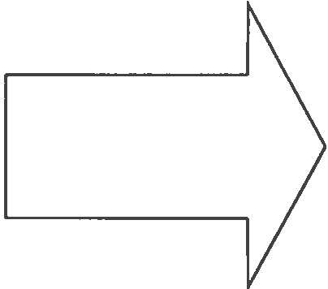

_ is always the independent variable.

_ is always the dependent variable.

Independent and Dependent Variables

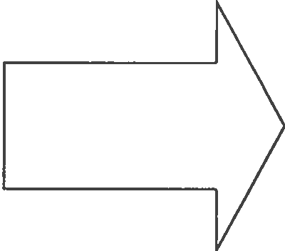

_ is always the independent variable.

_ is always the dependent variable.

Independent and Dependent Variables

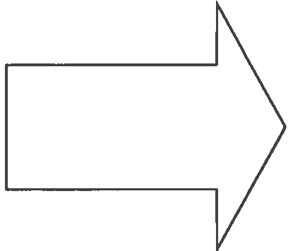

_ is always the independent variable.

_ is always the dependent variable.

Independent and Dependent Variables

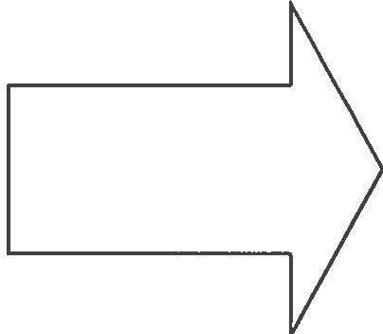

_ is always the independent variable.

_ is always the dependent variable.

Scientific Method - Manipulated and Responding Variables Page 1 of 1

Name: Date: _

Scientific Method - Manipulated and Responding Variables
Jordan is doing a science fair project on the effects of music on the growth of tomatoes. He has two tomato plants, Plant A and Plant B, that he grows in a window and gives the same amount of water. Plant A is exposed to classical music using headphones attached to the soil. Throughout the growth period, Jordan counts the number of tomatoes produced by each plant.
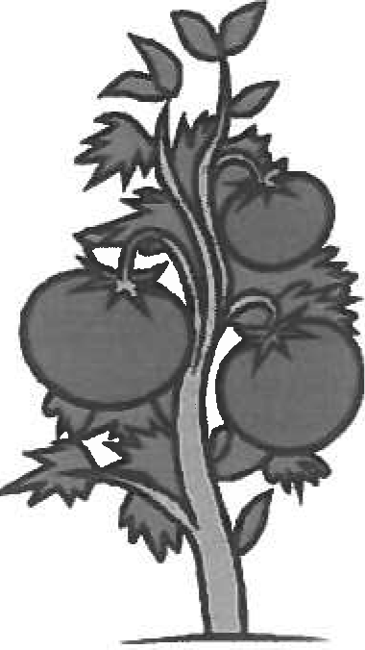

Plant A = 35 Tomatoes I Plant B = 55 Tomatoes
- What is the control group?

- What is the manipulated variable?

- What is the responding variable?

- What should Jordan's conclusion be? Write this in a complete sentence!

- Jordan needs to repeat the experiment, but his teacher says that he needs to improve his design. In his second experiment, what should he do different.

In the same science fair, Tina asks the question "Does caffeine increase the heart rate of an earthworm?" In Test 1, she measures the heart rate by looking at the earthworm under a microscopes, the earthworm has a heart rate of 50 bpm (beats per minute). In Test 2, she places a few drops of caffeine on the earthworm's skin and measures the rate again. In this test, the heart rate is 68 bpm.
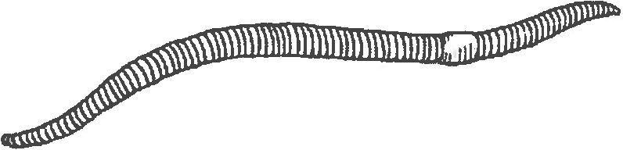

- What is the manipulated variable in this experiment?

- What is the responding variable in this experiment?

- Tina's experiment should have included a hypothesis. In a complete sentence, suggest a hypothesis for Tina's experiment.

http://www.biologycomer .com/worksheets/ controls_variables.html 3/20/2015
The Scientil/JC ••t/hJod

I ' '
lprocedure

' w,-.i:·

conclusion

4 , - .
-
•
•

IU

l l.L

IJ

14

hypothesis

experiment scientific method problems dependent analyze
data error

control

ACROSS
2. The _ describes the steps you use during an experiment.
4. The is a process used by scientists to find answers to questions or solve prob- lem.
7. Scientists use their data to make charts and to communicate the results of an experi- ment.
- The first step of the scientific method is to define or identify the .
- Sometimes scientist make a mistake, or , and need to do an experiment again.
- The variable is the part of the experiment that is affected by the independent variable.
- After the experiment, scientist organize and the data.
- The information collected during an experiment is called
- Scientist make to help them make a hypothesis or collect data during an experiment.

DOWN
1. The is the part of an experiment that is not being tested and is used for comparison.
3. After an experiment, scientist write a which summarizes their experiment and re- sults.
- The variable is the part of the experiment that is being tested or the part of that is changed by the person doing the experiment.
- The is an educated guess.
8. After the scientist make an hypothesis, they perform an to collect data.

edited-Susan Ging Lent

