Program Information | [Lesson Title]  Voter Turnout |  |  |  |  |  | TEACHER NAME  Judy Franks |  |  | PROGRAM NAME  Ohio Literacy Resource Center
Program Information | [Unit Title]  Voting Rights |  |  |  |  |  | NRS EFL  2 – 4 |  |  | TIME FRAME  60 – 180 minutes
Instruction | ABE/ASE Standards – Mathematics
Instruction | Numbers (N) |  |  |  | Algebra (A) |  | Geometry (G) |  |  | Data (D)
Instruction | Numbers and Operation |  |  |  | Operations and Algebraic Thinking |  | Geometric Shapes and Figures |  |  | Measurement and Data | D.2.5  D.2.4
Instruction | The Number System |  |  |  | Expressions and Equations |  | Congruence |  |  | Statistics and Probability
Instruction | Ratios and Proportional Relationships |  |  | N.4.9  N.4.12 | Functions |  | Similarity, Right Triangles. And Trigonometry |  |  | Benchmarks identified in RED are priority benchmarks. To view a complete list of priority benchmarks and related Ohio Aspire lesson plans, please see the Curriculum Alignments located on the Teacher Resource Center (TRC).
Instruction | Number and Quantity |  |  |  |  |  | Geometric Measurement and Dimensions
Instruction |  |  |  |  |  |  | Modeling with Geometry
Instruction | Mathematical Practices (MP)
Instruction |  | Make sense of problems and persevere in solving them. (MP.1) |  |  |  |  |  | Use appropriate tools strategically. (MP.5)
Instruction |  | Reason abstractly and quantitatively. (MP.2) |  |  |  |  |  | Attend to precision. (MP.6)
Instruction | □ | Construct viable arguments and critique the reasoning of others. (MP.3) |  |  |  |  |  | Look for and make use of structure. (MP.7)
Instruction |  | Model with mathematics. (MP.4) |  |  |  |  | □ | Look for and express regularity in repeated reasoning. (MP.8)
Instruction | LEARNER OUTCOME(S)  - The student will gather data about the 2012 presidential election results, then construct a graph to illustrate the data and predict/calculate the outcome of the election based on selected changes in voting patterns. |  |  |  |  |  | ASSESSMENT TOOLS/METHODS  - Analyze and Graph the Vote Worksheet  - Teacher Observation and Anecdotal Notes
Instruction | LEARNER PRIOR KNOWLEDGE  - Why don’t people vote? Use the Reasons for Not Voting to lead a discussion. What conclusions can we draw from this chart? What do your students know about reading charts and graphs?  - Based on standardized and informal assessments, students may need extra practice to increase graphing skills development.  - Basic understanding of percentages.
Instruction | INSTRUCTIONAL ACTIVITIES  - Introduce the Voter Turnout Charts. Study the first graph. Ask for volunteers to explain how to read a graph. Extract facts from the graph in the form of simple sentences and have students write down several sentences, such as “The highest turnout is from people who make $50,000 or more a year.” Have individuals share their sentences.  Teacher Note Data on the 2008 election can be found at Voting and Registration in the Election of November 2008. Info on the 2012 election can be found in the following pdf document: America Goes to the Polls, Voter Participation Gaps in the 2012 Presidential Election  Go through the other graphs in the same way. Get everyone to participate in determining the facts the graphs illustrate. When students share the sentences they wrote, ask them to explain why they thought those particular facts were important.  Lead a general discussion using these questions: What are these graphs about? What does this data tell you? What story do these graphs tell? For each graph: Are you surprised to see how the different groups compare? Why do you think some groups are so unlikely to vote? Which of these groups have the least power in the political process? Does this seem fair to you?  - Voter registration in the United States is at an all-time high but voter participation is nearing an all-time low. In the 1964 presidential elections 69.3 percent of the voting age population cast a ballot. In 2002, that number was only 54.7 percent, up .3 percent from 1996. The numbers for midterm elections are worse. During the midterm election of 1998, only 36.4 percent of the voting age population made it to the polls. See America Votes for more data. Also, state breakdowns of Voter Registration and Turnout Statistics are available from some of the sites mentioned in the resources. The Voter Turnout in Presidential Elections lists the voting percentages of the adult population back to 1828  - Have students examine the statistics and then discuss with a partner ideas why voter participation has decreased - each pair should record their theories. Give enough time for students to come up with several thoughtful ideas, then have partnerships share their thinking with the class. Ideas will vary, but may include theories such as people don't care about politics, people are too busy to study election issues, people are physically unable to get to the polls, etc. Construct charts together to organize the data.  Additional Practice Also, examine historical data and create a chart from the handout Ohio General Elections 1978-2014 Data Sheet. What themes are important to share in a visual format? What kind of graph is best for this information?  - What is voting like in your community? Have students use the United States Census Bureau website to research local voting statistics and trends, noting who tends to vote and who doesn't, voting percentages in community districts, etc. Instruct students to analyze the data to identify voting patterns, in particular, among groups of people who typically do not vote. Students might want to contact community organizations, advocates, and others who represent these populations to speak as panelists at a school- and/or community-based forum on the issue of under-representation in voting among these groups. Students could then work with these groups to increase participation, or alternatively, students could write press releases highlighting participation trends, speaking to their implications.  - When students are ready, have them complete the Analyze and Graph the Vote independently. The website Suburban Stats is a good source of data on the states. Use data with current population to predict election outcome. Use a calculator when necessary and make sure to check if work seems reasonable.  Additional Ideas/Extensions:  - Help students register to vote.  - Graph election data from eastern states, neighboring states, counties in Ohio, or different parts of Ohio.  - Graph the voting percentages in presidential elections found in the Voter Turnout in Presidential Elections.  - Using the website 270 to Win compare the differences in the electoral vote and popular vote between the winners and losers.  - Write ratios using the election results. |  |  |  |  |  | RESOURCES  Projector, ability to project  Reasons Given for Not Voting (attached)  Voter Turnout Charts (attached)  Fille, T., & Crissey, S. (2012, July). Voting and Registration in the Election of November 2008 [PDF file]. Retrieved from http://www.census.gov/prod/2010pubs/p20-562.pdf  NonProfitVote. (n.d.). America Goes to the Polls: Voter Participation Gaps in the 2012 Presidential Election [PDF file]. Retrieved from http://www.nonprofitvote.org/documents/2013/09/america-goes-to-the-polls-2012-voter-participation-gaps-in-the-2012-presidential-election.pdf  PBS.org. (n.d.). America Votes. Retrieved from http://www.pbs.org/now/politics/votestats.html  The American Presidency Project. (n.d.). Voter Turnout in Presidential Elections. Retrieved from http://www.presidency.ucsb.edu/data/turnout.php  Student copies of Ohio General Elections 1978-2014 Data Sheet (attached)  Student copies of Analyze and Graph the Vote (attached)  Calculators for student use
DIFFERENTIATION

- Students can complete the entire lesson with a partner.
- Complete calculations on Analyze and Graph Data using whole numbers.
- If necessary, provide assistance calculating percentages in questions 3b and 3c and setting up the scale on the graphs developed.
- Upper level students can use the data in the chart "Reasons for Not Voting" to construct a circle or 100% graph.

Reflection | TEACHER REFLECTION/LESSON EVALUATION  There are lots of great opportunities for ELA practice on the topic of voting. Students will practice reading graphs in Social Studies with this lesson.
Reflection | Additional Information  - Have the students select an additional state to use to complete the Analyze and Graph Data Handout. Use the data from the last election and calculate what percentage of change in votes would be required to change the outcome.  - Ask the student to graph election results based on demographics (e.g., age group, sex, race, religious preference).  - Have the student create several different graphs and discuss how easy they are to interpret  - Students can practice graphing and understanding voting rates at the Voter Turnout Learning Objects.

0.8
18.9
Reasons Given for Not Voting
(Percent of registered voters who didn't vote)

Too Busy–Conflicting Schedule
15.7
Not Interested

14
Illness or Disability

12.7
Don’t Like Candidates
11.1
Other Reason

8.6
Out of Town

5.5
Registration Problems
Forgot
3.9
3.3
Transportation Problems

2.7
3.0
Bad Weather
Inconvenient Polling Place
Don’t Know or Refused
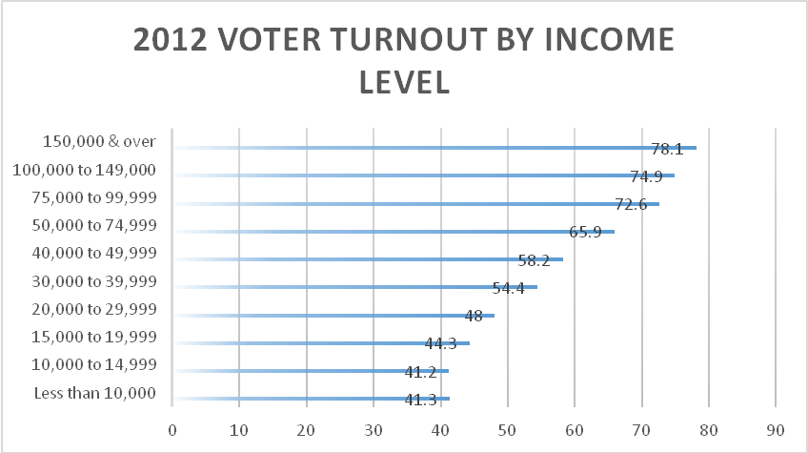

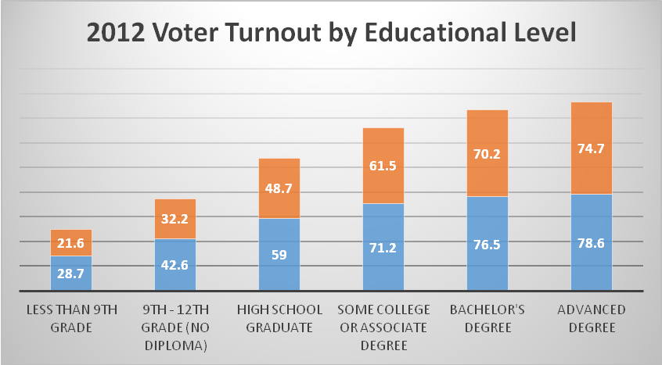

Blue bar represents % who registered, orange bar represents % who voted

Voter Turnout Charts

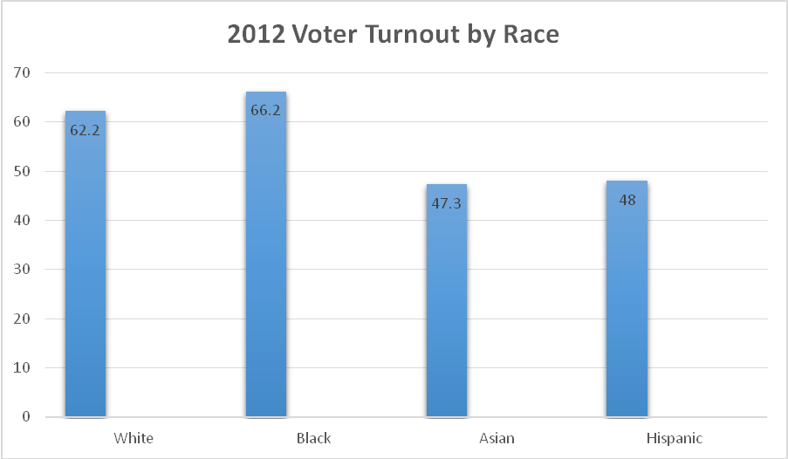

Voter Turnout Charts

Ohio General Elections 1978-2014 Data Sheet

Election Year Registered Voters Electors Voting Percent Voting
1978 5,181,910 3,017,700 58.24%
1979 5,402,722 2,964,924 54.88%
1980 5,962,864 4,378,937 73.88%
1981 5,640,544 2,906,824 51.53%
1982 5,694,775 3,551,995 62.37%
1983 5,828,004 3,499,354 60.04%
1984 6,332,454 4,664,223 73.66%
1985 6,082,980 2,564,623 42.16%
1986 5,996,430 3,261,870 54.40%
1987 5,822,189 2,759,276 47.39%
1988 6,275,638 4,505,284 71.79%
1989 5,830,757 2,840,926 48.7%
1990 5,912,746 3,620,469 61.23%
1991 5,820,133 2,983,565 51.26%
1992 6,536,936 5,043,094 77.14%
1993 6,204,103 2,815,567 45.38%
1994 6,231,724 3,570,391 57.29%
1995 6,416,133 2,774,300 43.35%
1996 6,879,687 4,638,108 67.41%
1997 7,022,866 3,128,446 44.54%
1998 7,096,423 3,534,782 49.81%
1999 7,146,985 2,467,736 34.53%
2000 7,531,555 4,800,009 63.73%
2001 7,153,796 2,574,915 35.99%
2002 7,113,826 3,356,258 47.81%
2003 7,138,932 2,614,354 36.62%
2004 7,972,826 5,722,443 71.77%
2005 7,684,320 3,093,968 40.26%
2006 7,860,052 4,184,072 53.23%
2007 7,772,654 2,436,070 31.34%
2008 8,287,665 5,773,777 69.97%
2009 8,041,612 3,292,374 44.64%
2010 8,037,806 3,956,045 49.22%
2011 7,709,478 3,628,342 47.06%
2012 7,987,203 5,633,246 70.53% 2013 7,702,189 2,077,619 26.97%
2014 7,748,201 3,149,876 40.65%

Additional Resource
Ohio Historical Election Data
http://www.sos.state.oh.us/sos/elections/Research/electResultsMain.aspx

Analyze and Graph the Vote

Use the 2012 Presidential election data for Ohio (http://www.politico.com/2012-election/results/president/ohio/) to answer the following.

- Find the 2012 presidential election results for Ohio by political party. How many ways can you report this data? Why did you choose to report the data in the way you did?

- Use the state election data to construct a graph of your choice (bar, circle, line, or pictograph).

- Analyze the graph and data to answer the following questions and make predictions.

- How many more votes did the Republican candidate need to win Ohio?

- What percentage of the total votes would this be?

- If the state kept the same percentage of voters as in the 2012 election for each candidate, what would be the number of voters for each candidate using the current Ohio population?

- If all voters who voted for an alternative party candidate switched their votes to the Republican candidate, would Ohio's electoral votes been awarded to a different candidate?

- How do the election results in your home county compare to the Ohio results?



http://www.wisconline.org

Line Graphs
Author: Barbara Laedtke
School: Fox Valley Technical College Date: 9/16/2002
Description: Learners read an explanation of line graphs and demonstrate their knowledge of the parts of a graph in an interactive exercise.
http://www.wisc-online.com/objects/index_tj.asp?objID=SOC302

Interpreting Line Graphs
Author: Barbara Laedtke
School: Fox Valley Technical College Date: 4/19/2002
Description: Students analyze line graphs and answer questions about the information shown.
http://www.wisc-online.com/objects/index_tj.asp?objID=SOC702

Reading and Interpreting Bar Graphs
Author: Francine Nettesheim
School: Northcentral Technical College Date: 7/10/2002
Description: Students identify the various parts of a bar graph, read and interpret data presented in a bar graph, and calculate the data to solve various application problems.
http://www.wisc-online.com/objects/index_tj.asp?objID=ABM3802

Understanding Voting Rates
Author: Barbara Laedtke
School: Fox Valley Technical College Date: 8/4/2005
Description: Students examine how voting rates are determined and how those rates change depending upon the population being studied. A brief quiz completes the activity.
http://www.wisc-online.com/objects/index_tj.asp?objID=SOC6005

Voter Turnout Learning Objects

