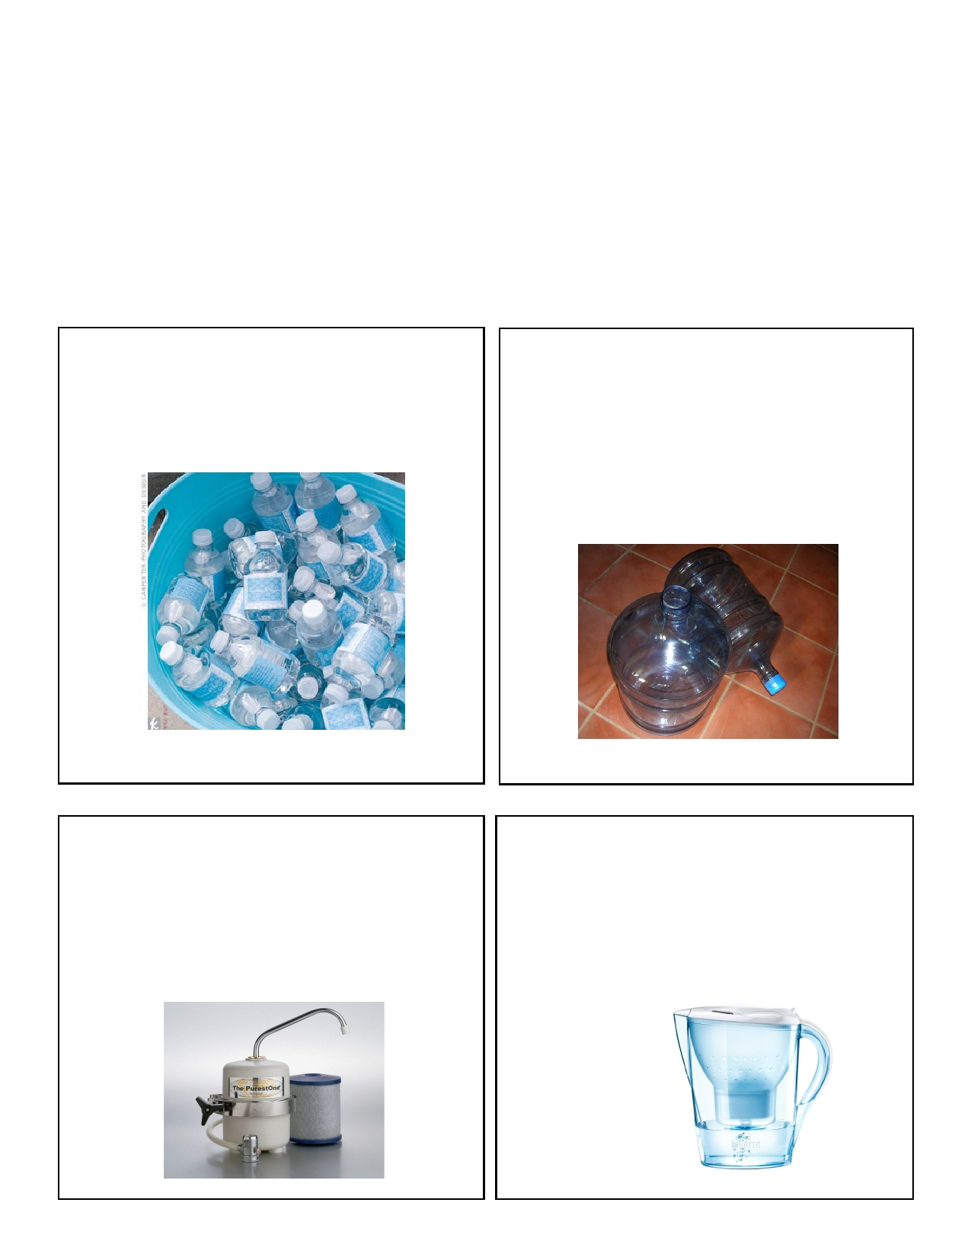
Water Evaluation Task
You never thought it would come to this, but you are ready to start buying water. After checking the EPA
reports for your local area, you decide to go with some form of purified water. Assume that you are mak- ing a decision for the next 3 to 6 years, and that your household will be drinking about 2 gallons of water per day. (Remember that 128 ounces = 1 gallon).
1. Construct a chart or graph that would be effective in helping you make a decision.
2. Determine which clean water source represents the best deal and explain why.

Option 1. Bottled water

Cases of thirty 16.9 ounce bottles of water are sold for $15
each, plus 6% sales tax. However, if you buy 3, you get 1 free.

Option 3. Water purification system

A water system built directly into your sink will cost $1329.37, regular price, tax included. Filters and maintenance total (with
tax) about $28/year. Right now, you can receive a 15% discount on a system.

Option 2. Water machine

Agua Limpia will come to your house and install a machine for
free, but you must sign a contract to purchase a minimum of four 20-gallon jugs per month. Each jug is $6.95, tax included. You can cancel the contract at any time with no penalty. Agua Limpia will cover all service fees

Option 4. Purifier jug for the fridge

The jug itself is $13.98 (with no filters), and 3-packs of filters
sell for $19.99 each. Neither of those amounts include the 6% sales tax. Also, to avoid bacteria growing inside the filter, you will need to change it every 2 months or 50 gallons, whichever comes first.

