The History of Money

http://www.minneapolisfed.org/econed/curric/history.cfm

Consider this problem:
You catch fish for your food supply, but you're tired of eating it every day. Instead you want to eat some bread. Fortunately, a baker lives next door. Trading the baker some fish for bread is an example of barter, the direct exchange of one good for another.
However, barter is difficult when you try to obtain a good from a producer that doesn't want what you have. For example, how do you get shoes if the shoemaker doesn't like fish? The series of trades required to obtain shoes could be complicated and time consuming.
Early societies faced these problems. The solution was money. Money is an item, or commodity, that is agreed to be accepted in trade. Over the years, people have used a wide variety of items for money, such as seashells, beads, tea, fish hooks, fur, cattle and even tobacco.

Coins
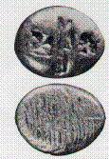
Lydian Coin (Western Turkey), 700-637 B.C.
Most early cultures traded precious metals. In 2500 BC the Egyptians produced metal rings for use as money. By 700 BC, a group of seafaring people called the Lydians became the first in the Western world to make coins. The Lydians used coins to expand their vast trading empire (see picture above). The Greeks and Romans continued the coining tradition and passed it on to later Western civilizations (see picture below). Coins were appealing since they were durable, easy to carry and contained valuable metals.
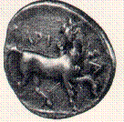
Dracma, Thessaly (Eastern Greece), 400-344 BC
During the 18th century, coins became popular throughout Europe as trading grew. One of the most widely used coins was the Spanish 8-reale. It was often split into pieces or bits to make change. Half a coin was 4 bits, a quarter was 2 bits, a term still used today.
Coins containing precious metals are an example of "commodity money." The item was traded because it held value. For example, the value of the coin depended upon the amount of gold and silver it contained.

Paper currency
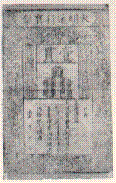
Chinese note 1368-1399 (size of a sheet of notebook paper)
The Chinese were the first to use paper money, beginning in the T'ang Dynasty (618-907 A.D.). During the Ming Dynasty in 1300 AD, the Chinese placed the emperor's seal and signatures of the treasurers on a crude paper made from mulberry bark. (see picture above).
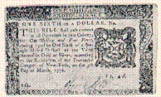
New York Note, 1776
Representative money is tokens or pieces of paper that are not intrinsically valuable themselves, but can be exchanged for a specific commodity, such as gold or silver. In 1715 Maryland, North Carolina and Virginia issued a "tobacco note" which could be converted to a certain amount of tobacco. This type of money was easier to make large payments and carry than coin or tobacco leaves.
In the late 1800s, the U.S. government issued gold and silver certificates (see picture below).
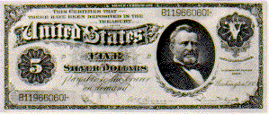
Silver Certificate 1886 (worth $5 of silver)
Fiat money is similar to representative money except it can't be redeemed for a commodity, such as gold or silver. The Federal Reserve notes we use today are an example of fiat money. In 1967 Congress authorized the US Treasury to stop redeeming silver certificates in silver dollars or bullion beginning the following year. By 1970 silver was removed from the production of coins. The old coins were gradually removed from circulation and replaced with new copper-cored coins that were faced or “clad” with layers of an alloy of 75 percent copper and 25 percent nickel—the same alloy used in nickels.
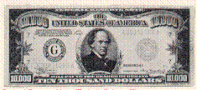
$10,000 Federal Reserve Note 1934 (no longer in print).
Portrait of Salmon Chase, Treasury Secretary 1861-1864
People are willing to accept fiat money in exchange for the goods and services they sell only because they are confident it will be honored when they buy goods and services. The Federal Reserve is responsible for maintaining the integrity of US currency by setting monetary policy —controlling the amount of money in circulation—to keep prices stable. If prices remain stable, people have confidence that the dollar they use to buy goods and services today will buy a similar amount in the future.
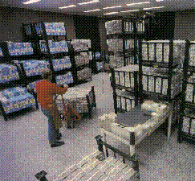
The vault at a Federal Reserve Bank

Money serves three purposes:
Medium of Exchange
People accept money in trade for goods and services.

Standard of Value
The value of a good or service can be measured with money. For example, a car with a price of $2,000 is worth twice as much as a car with a price of $1,000.

Store of Value
Money can be saved and used in the future.

